Since the creation of the blockchain to the apparition of Bitcoin, Ethereum and smart contracts have passed just two decades. This puts in perspective that blockchain is still a mature technology which is emerging to create new business opportunities. [1] Claims the large number of companies and business models that are implementing this new blockchain technology into many different topics. Focusing the attention into the energy sector, The German Energy Agency [2] states that the utilisation of blockchain can improve the efficiency of the current energy companies’ operations as well as the peer-to-peer (P2P) energy trading. Some of them are billing, trading and markets, smart grid applications, grid managements, among others. Thus, blockchain provides us a wide range of possibilities and opportunities, being now in the niche market and going to the mass market where in a near future blockchain and Internet of things (Iot) will be as common as Internet is to us nowadays.

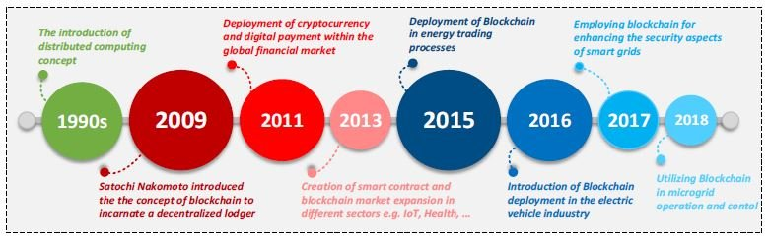

**Figure 1.** Time line of main events related with blockchain [3].

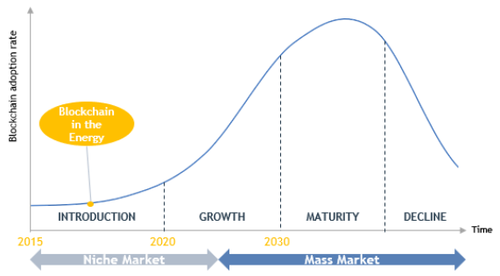

**Figure 2.** Evolution of blockchain in the energy market [1].

[1], [4] and [5] explain really well what is and how it works a blockchain, as well as what is a Bitcoin and other cryptocurrencies. However, this work focuses on a way to apply the concept of blockchain to the energy sector. This manner is possible with smart contracts, [4] an application of the blockchain technology that lets interchange more than cryptocurrencies between two peers i.g. allowance to sell and buy energy from peer-to-peer with the reliability and security that provides blockchain. In other words, it is a way to enhance the participation of prosumers in the energy market, favouring a semi-decentralised electric system which approaches the generation to the consumption. Actually, some projects have been proposed but not yet implemented as [4] or [6], but still needing to face some difficulties like regulatory, economics and technology issues.

To accomplish a reliable and secure energy trading, some requirements need to be faced, such as the creation of the smart contract, the communication among peers, a possible agreement with the grid company, etc. Until this moment, it has been done smart contracts of energy trading and an app to connect peers as [4] or [6]. However, they are just ideas without a real application. It is not quite sure how to reach an agreement with the electricity grid company to let the prosumers sell and buy energy using a smart contract. Moreover, once multiple prosumers participate in the semi-decentralised system, a fast and optimal power flow should be required, and yet this technology is mature.

Having exposed what has been done and what is still required, in this small report it is intended to step up the current investigations, enhancing the idea of a smart contract to sell and buy energy among different peers and combining it with a greater power flow system proposed, the Proper Generalized Decomposition (PGD) methodology which will be explained in the following chapters.

References

[1] A. Faugeras, “State of the Art Report Smart Contract and Blockchain Document Status,” 2019.

[2] C. Burger, A. Kuhlmann, P. R. Richard, and J. Weinmann, “Blockchain in the energy transition. A survey among decision-makers in the German energy industry,” *Ger. Energy Agency*, no. May 2020, p. 41, 2016, [Online]. Available: www.esmt.org.

[3] A. S. Musleh, G. Yao, and S. M. Muyeen, “Blockchain Applications in Smart Grid-Review and Frameworks,” *IEEE Access*, vol. 7, no. June, pp. 86746–86757, 2019, doi: 10.1109/ACCESS.2019.2920682.

[4] K. Komal, “Blockchain based Peer-to-Peer Energy Trading using IoT devices,” p. 110, 2019.

[5] C. Udokwu, A. Kormiltsyn, K. Thangalimodzi, and A. Norta, “An Exploration of Blockchain enabled Smart-Contracts Application in the Enterprise,” *Tech. …*, no. June, pp. 1–28, 2018, doi: 10.13140/RG.2.2.36464.97287.

[6] I. El-Sayed, K. Khan, X. Dominguez, and P. Arboleya, “A real pilot-platform implementation for blockchain-based peer-to-peer energy trading,” *IEEE Power Energy Soc. Gen. Meet.*, vol. 2020-Augus, 2020, doi: 10.1109/PESGM41954.2020.9281855.